**Name:** Nnadiekwe Chiderah David

Launching instances using AWS CLI

* ***Configure the AWS CLI with your AWS access key ID, secret access key, and region.Shape, rectangle

  Description automatically generated***
* ***Use the aws ec2 run-instances command to launch a new EC2 instance. You can choose any Amazon Machine Image (AMI) that includes a Linux distribution, such as Amazon Linux 2. Be sure to specify the instance type, key pair, and security group(s) in the command.***
* Add a tag to the instance with the key Name and the value my-ec2-created-through-CLI.

* ***Inputting the parameters to run the ec2 instance on VSCode***

***I Pasted the codes from vscode to the CLI command prompt interface***

***The response is seen below:***

* ***SSH into the instance using the key pair you specified in step 3 and verify that you can access the instance.***

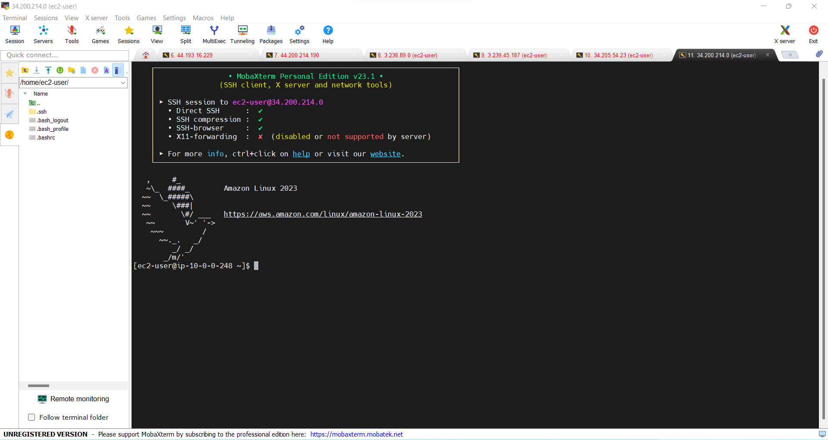

* ***Take a screenshot of your terminal showing the output of the aws ec2 describe-instance command and submit it as proof of completion.***

